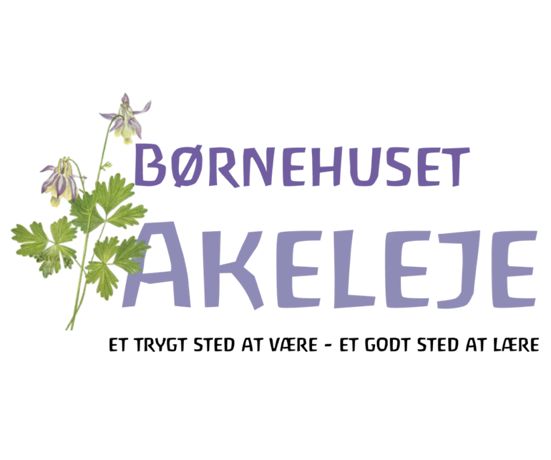

ÅRSTIDSFEST – ARBEJDSPLAN OG LÆRINGSMÅL

Hvad er baggrunden for festen?

1. Ifølge antroposofien – hvilken stemning er der tale om:

____________________________________________________________________

____________________________________________________________________

____________________________________________________________________

____________________________________________________________________

____________________________________________________________________

2. Årstidsfesten året før (se på evaluering), hvad skal forbedres, justeres, gentages, udvikles?

____________________________________________________________________

____________________________________________________________________

____________________________________________________________________

____________________________________________________________________

____________________________________________________________________

3. Børnemiljø nu – hvad skal vi se af aktuelle fokuspunkter ud fra vores:

A. Børnemøder _________________________________________________________
____________________________________________________________________

B. Observationsbøger ____________________________________________________

____________________________________________________________________

C. Samtaler ___________________________________________________________

____________________________________________________________________

____________________________________________________________________

4. Hvilke læreplanstemaer vil vi fokusere på ud fra ovenstående observationer og steinerpædagogik, så der foregår læring hele dagen?

1. De voksenstyrede aktiviteter ______________________________________________
____________________________________________________________________

____________________________________________________________________

____________________________________________________________________

2. Daglige rutiner _______________________________________________________

____________________________________________________________________

____________________________________________________________________

____________________________________________________________________

3. Legen _____________________________________________________________

____________________________________________________________________

____________________________________________________________________

____________________________________________________________________

5. Teamets selvskoling – hvilke mål har jeg for mig selv i denne periode? (ift. Barn, kollega, forældre, teori, kompetence, min egen viden, hvilke sider vil jeg blive mere bevidst om i mig selv?)

____________________________________________________________________

____________________________________________________________________

____________________________________________________________________

____________________________________________________________________

____________________________________________________________________

____________________________________________________________________

____________________________________________________________________

____________________________________________________________________

____________________________________________________________________

____________________________________________________________________

6. Kreative forberedelser
 | Ansvar | Hvem hjælper til | Deadline
Indkøb
Mad
Skaffe ting fra naturen
Blomster
Pynte årstidsbord
Pynte stue
Program for festen
Pynte op til festen
Sanglegsprogram
Eventyr og fortællinger
Voksensange
Opslagstavle

Ugerne op til festen/inddragelse af lokalsamfundet ___________________________

____________________________________________________________________

____________________________________________________________________

____________________________________________________________________

____________________________________________________________________

____________________________________________________________________

7. Selve festen

Voksenfordeling-roller og opgaver ____________________________________________
____________________________________________________________________

Oprydning-hvornår og hvem ________________________________________________

____________________________________________________________________

Børn med specielle behov __________________________________________________

____________________________________________________________________

____________________________________________________________________

8. Dokumentation

Hvordan vil vi dokumentere processen/produkter (film, foto, børneinterview, lydoptagelser)? ___
____________________________________________________________________

____________________________________________________________________
____________________________________________________________________
Til hvad skal dokumentationen bruges (evaluering af børnemiljø, læringsmål, forældre, opslagstavle, hjemmeside/marketing, bevidsthed om egen praksis? _____________________
____________________________________________________________________

____________________________________________________________________
____________________________________________________________________

9. Evaluering

Af samarbejde og stemning i voksenhøjde _______________________________________
____________________________________________________________________

____________________________________________________________________

____________________________________________________________________

Nåede vi målene fra læreplanstemaer? _________________________________________
____________________________________________________________________

____________________________________________________________________

____________________________________________________________________

Hvor kan vi se/måle læringen? ______________________________________________

____________________________________________________________________

____________________________________________________________________

____________________________________________________________________
Er der områder, vi skal arbejde videre med? _____________________________________

____________________________________________________________________

____________________________________________________________________

____________________________________________________________________

